**Importing Libraries**

First, you need to import the essential libraries. Here are some commonly used libraries for data preprocessing:

### Loading the Data

Assuming you have a CSV file, you can load the dataset using Pandas:

### Exploring the Data

It's important to understand the structure of your data. You can use the following commands to get an overview:

### Handling Missing Values and etc

Check for missing values and decide how to handle them. You can fill missing values, drop them, or use imputation techniques:

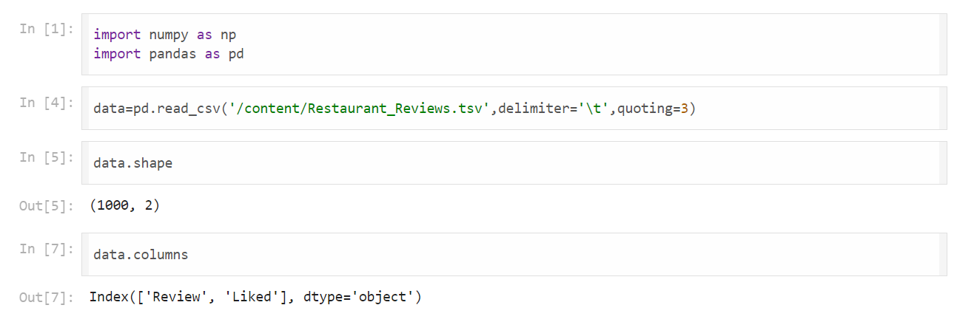

**Import the necessary libraries.**

**Download the stopwords dataset.**

**Load the stopwords and initialize the stemmer.**

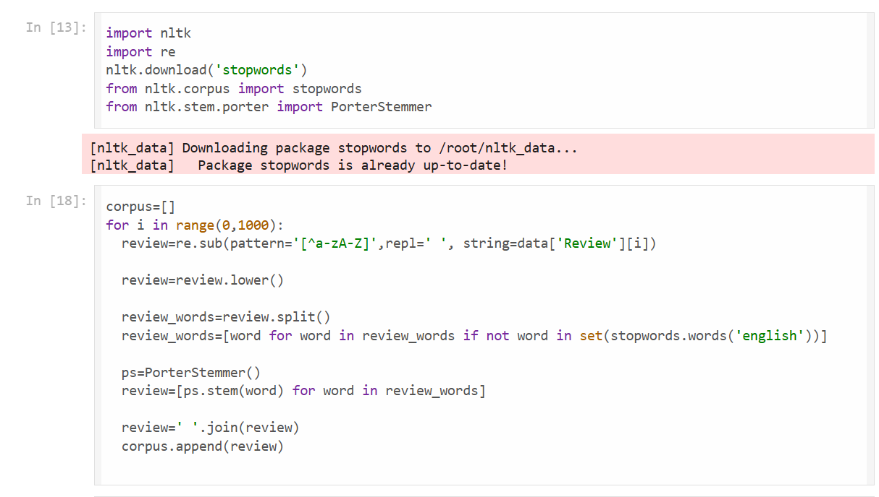

Your code snippet aims to preprocess text data from a DataFrame by performing several steps: removing non-alphabetic characters, converting text to lowercase, removing stopwords, applying stemming, and joining the processed words back into a string. This preprocessed text is then appended to a list called corpus. Below is a refined and complete example, incorporating error handling and best practices.

Your code snippet shows how to convert the preprocessed text data (corpus) into a numerical format using CountVectorizer from Scikit-learn, and then extract the target variable y from the DataFrame. This is a common step when preparing text data for machine learning models. Here is the complete process, combining the previous text preprocessing steps with the creation of the feature matrix and target vector.